Swinburne University of Technology

COS30045 - Data Visualisation

Lab Exercise Demonstration 3

(Exercises 5.1 - 6.2)

Student: Nguyen Anh Duc – 103488489

Lecturer: Ms. Nguyen Thuy Linh

Tutor: Mr. Vu Ngoc Binh

Lab 6.1
<!DOCTYPE html>
<html lang="en">

<head>
<meta charset="UTF-8" />
<meta name="description" content="Data Visualisation Exercise 1" />
<meta name="keywords" content="HTML, CSS" />
<meta name="author" content="Your name here" />

<title>Task 6.1 D3 Interactivity - Mouse Over Effects</title>
<script src="https://d3js.org/d3.v7.min.js"></script>

<style>
button {
border: none;
color: white;
padding: 10px 20px;
text-align: center;
text-decoration: none;
display: inline-block;
font-size: 16px;
margin: 10px 5px;
cursor: pointer;
border-radius: 5px;
transition-duration: 0.4s;
}

#add {
background-color: #4CAF50;
}

#add:hover {
background-color: #45a049;
}

#remove {
background-color: #2196F3;

}

#remove:hover {
background-color: #0b7dda;
}

svg {
margin-top: 20px;
}
</style>

</head>

<body>
<h1>Bar Chart with Mouse Over</h1>
<button id="add">Add</button>
<button id="remove">Remove</button>
<br>

<script>
// example from Murray
var dataset = [20, 5, 26, 23, 9, 23, 16, 4, 29];
var w = 500;
var h = 150;
var padding = 1;
var maxValue = 25;

var xScale = d3.scaleBand()
.domain(d3.range(dataset.length))
.rangeRound([0, w])
.paddingInner(0.05);

var yScale = d3.scaleLinear()
.domain([0, d3.max(dataset, function (d) {
return d;
})]) // The data input range
.range([0, 150]); // The range available for visualization on screen

var svg1 = d3.select("body")
.append("svg")
.attr("width", w)
.attr("height", h);

//initial bars
svg1.selectAll("rect")
.data(dataset)
.enter()
.append("rect")
.attr("x", function (d, i) {
return xScale(i);
})
.attr("y", function (d) {
return h - yScale(d);
})
.attr("width", xScale.bandwidth())
.attr("height", function (d) {
return yScale(d);
})
.attr("fill", "teal")
.on("mouseover", function (event, d) {

// Get the position of the bar
var xPosition = parseFloat(d3.select(this).attr("x")) + xScale.bandwidth() / 2;
var yPosition = parseFloat(d3.select(this).attr("y")) + 15; // Move tooltip above the bar

// Add new tooltip to the póition
svg1.append("text")
.attr("id", "tooltip")
.attr("x", xPosition)
.attr("y", yPosition)
.attr("text-anchor", "middle")
.attr("font-family", "sans-serif")
.attr("font-size", "13px")
.attr("fill", "black")
.text(d);

//change bar to orange
d3.select(this)
.transition().duration(200)
.attr("fill", "orange");

})
.on("mouseout", function () {
// Remove the tooltip when the mouse moves out
d3.select("#tooltip").remove();

//back to teal
d3.select(this)
.transition().duration(200)
.attr("fill", "teal");
});

//update chart after button clicked
function updateChart() {
xScale.domain(d3.range(dataset.length))

// Update the Y scale based on new data
yScale.domain([0, d3.max(dataset)]);

//update bars
var bars = svg1.selectAll("rect")
.data(dataset);

//add bars
bars.enter()
.append("rect")
.attr("x", w)
.attr("y", function (d) {
return h - yScale(d);
})
.attr("fill", "teal")
.merge(bars)
.transition()
.duration(200)
.attr("x", function (d, i) {
return xScale(i);
})
.attr("y", function (d) {
return h - yScale(d);
})
.attr("width", xScale.bandwidth())
.attr("height", function (d) {
return yScale(d);
});

// Add mouseover and mouseout effect to both old and new bars
svg1.selectAll("rect")
.on("mouseover", function (event, d) {
// Get the position of the bar
var xPosition = parseFloat(d3.select(this).attr("x")) + xScale.bandwidth() / 2;
var yPosition = parseFloat(d3.select(this).attr("y")) + 15; // Move tooltip above the bar

// Add new tooltip
svg1.append("text")
.attr("id", "tooltip")
.attr("x", xPosition)
.attr("y", yPosition)
.attr("text-anchor", "middle")
.attr("font-family", "sans-serif")
.attr("font-size", "13px")
.attr("fill", "black")
.text(d);

d3.select(this)
.transition().duration(200)
.attr("fill", "orange");
})
.on("mouseout", function () {
// Remove the tooltip when the mouse moves out
d3.select("#tooltip").remove();

//back to teal
d3.select(this)
.transition().duration(200)
.attr("fill", "teal");
});

// Exit bars
bars.exit()
.transition()
.duration(200)
.attr("x", w)
.remove();
}

// Add new data button
d3.select("#add").on("click", function () {

var newNumber = Math.floor(Math.random() * maxValue);
dataset.push(newNumber);
updateChart();
});

// Remove data button
d3.select("#remove").on("click", function () {
dataset.shift();
updateChart();
});

</script>

<br><br>
<footer style="color:grey">COS30045 Data Visualisation<br>Joe Bloggs</footer>

</body>

</html>

Initial bar chart with the first bar being hovered:
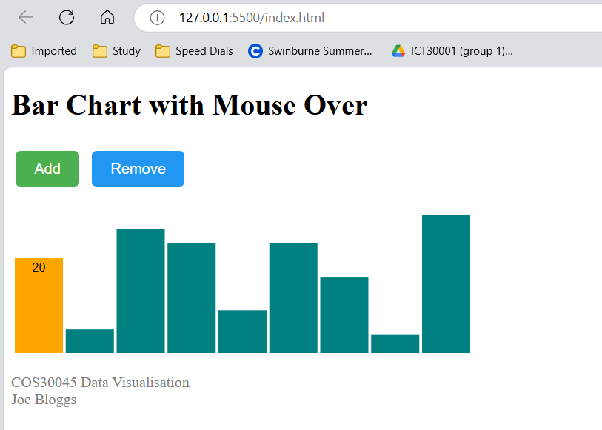

This is when a new bar is added and hovered:
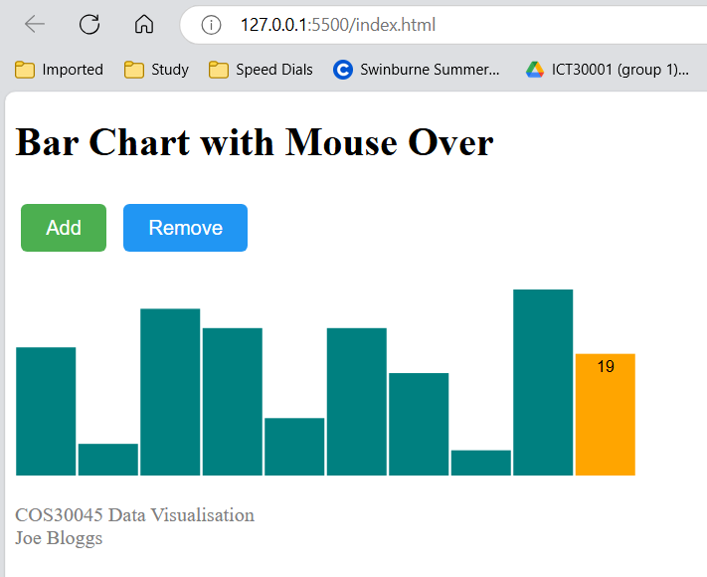

This is when the first bar (20) is removed:
